Custom Tile for O365 App Launcher

You can add your own custom Tiles to the app launcher that point to SharePoint sites, external sites, legacy apps, and more. The custom Tile appears under the app launcher's All apps, but you can pin it to the Home apps.

**Note :  Still O365 doesn’t support Admin user to pin custom Tiles to all users, but it’s in the O365 roadmap.**

<https://products.office.com/en-us/business/office-365-roadmap>

Steps

1. Add custom Tile
2. Promote the Tile to the Home tab
3. Rearrange custom Tile

**1. Add custom Tile**

1. Go to O365 **Admin** center.
2. Choose **Settings** > **Organization profile** > **Add custom tiles for your organization**.

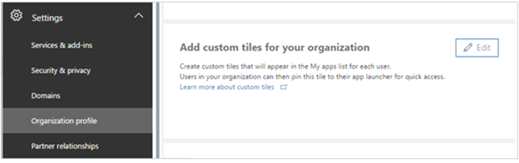

1. Choose + **Add a custom tile**.

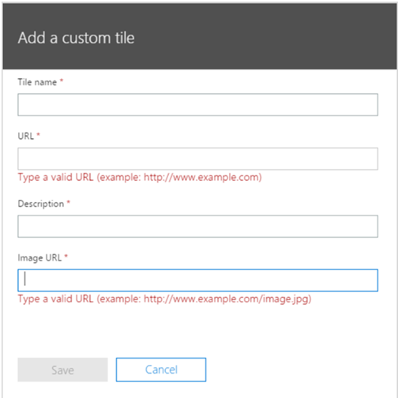

1. Enter a **Tile name** for the new tile. The name will appear in the tile.
2. Enter a **URL** for the tile. This is the location where you want your users to go when they click the tile on the app launcher.
3. Enter a **Description** for the tile. You see this when you select the tile on the My apps page and choose App details.
4. Enter an **Image URL** for the tile. The image appears on the apps page and app launcher.
5. Choose **Save** to create the custom tile.

**2. Promote the Tile to the Home tab**

1. Select the app launcher icon and select the **Home** tab.
2. Locate the new tile for your app, select the ellipsis, and choose **Pin to home.**

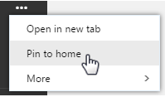

**3. Rearrange custom Tile**

1. Choose the Tile that you want to move.
2. Drag it to where you want it to appear on the app launcher.

**References:**

<https://support.office.com/en-us/article/Add-custom-tiles-to-the-app-launcher-1136115a-75af-4497-b693-640c4ce70bc6>

<https://support.office.com/en-us/article/Change-the-order-of-your-tiles-on-the-Office-365-app-launcher-07a83bef-9710-4e3d-851d-419dd04201fd?ui=en-US&rs=en-US&ad=US>